**SHRI G.S. INSTITUTE OF TECHNOLOGY & SCIENCE, INDORE**

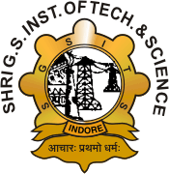

**DEPARTMENT OF COMPUTER ENGINEERING**

**B. Tech. (Computer Science & Engineering)**

**CO 34481**

**INTERNSHIP – I**

**NAME :** Abhay Bamboriya

**ENROLLMENT NO. :** 0801CS221002

**Certificate of Completion**

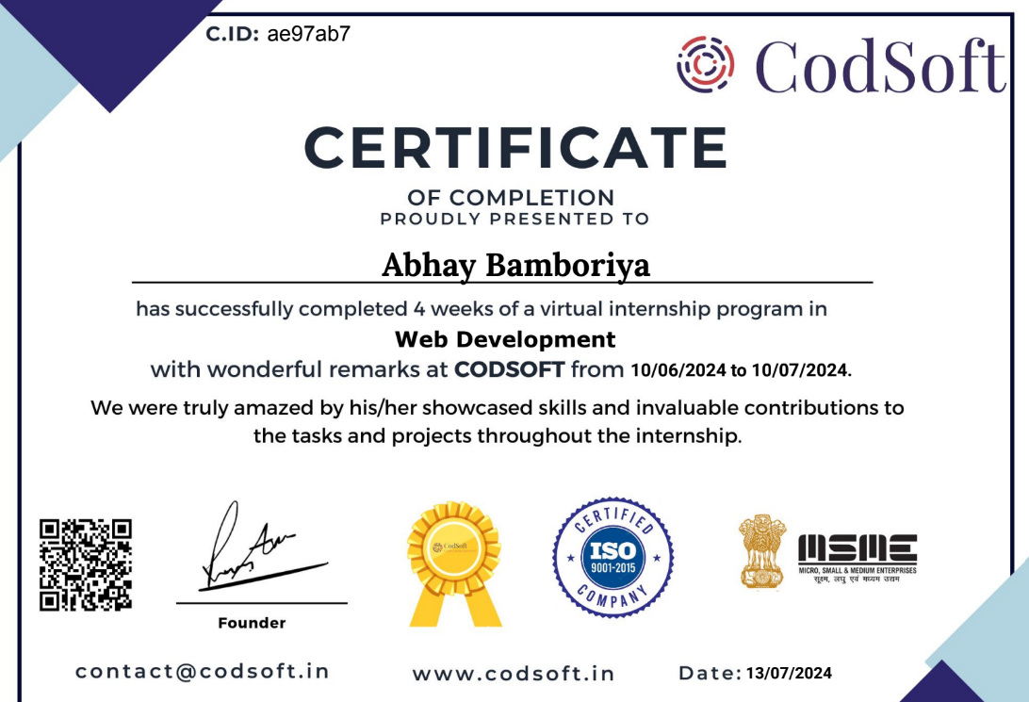

**COMPANY DETAILS**

|  |  |  |
| --- | --- | --- |
| Details | |  |
|  | |  |
| Name | | Codsoft Pvt. Ltd. |  |
| Address | | Lokenath bose garden lane Kolkata,West Bengal |
| **Contact information** | |  |
| Website URL | | www.codsoft.in |
|  |
|  | |  |

**INTERNSHIP SUMMARY**

i

|  |  |  |
| --- | --- | --- |
| Summary | |  |
|  | |  |
| Title | | Full Stack Web Development |  |
| Duration  Start Date | | 1 Months  10-June-2024 |
| End Date | | 10-July-2024 |
| Technologies Used | | MERN STACK |
|  |
|  | |  |

**Learning Outcomes**

Following are the learning Outcome :-

* Front-End Development
* Responsive Design Implementation
* Backend Development
* API Development
* Security Measures
* Schema Design
* CRUD Operations
* React
* React Redux

**References**

https://www.linkedin.com/